# **I. SOFTWARE OVERVIEW**

**1.1 Software general requirements**

General requirements of the hotel management system software consists of two parts: room management; information management in the database.

a) Room management:

- Processing guest's booking process: check, find room for guests, changing room request.

- Enter customer information for booking.

- Payment and invoice printing for guests

b) Management of information in the database

- Management, updating information staff, services, rooms in the hotel and discount promotions (if any).

- Manage turnover statistics by day, month, quarter.

- Manage turnover statistics by room.

- Administering user access permissions by functional group: includes "Management" and "Receptionist". User can change password to access the system.

- Store the list of customers who have reservations in the hotel.

- Store the list of services used by customer to check invoices

- Store invoices that have been paid out over time for future reporting.

**1.2 Software objectives**

Small and low professional level hotel and motel. Help the management to be more effectively, accurately and quickly.

**1.3. User**

System has these user group:

- Management team: control at the whole system.

- Professional operation group:

+ Receptionist: check availability, enter customer information, book rooms, book services, check out and billing for guests.

+ Customer: Direct reservations or by telephone, call to Receptionist to request service.

**1.4. Software overall model**

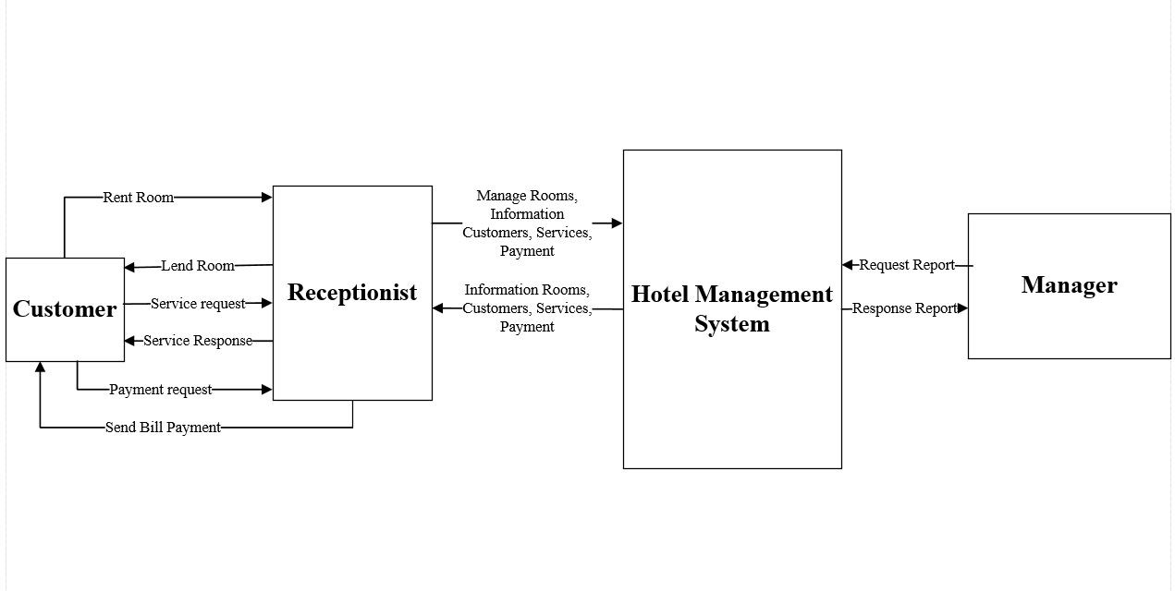

**H1.** **Software overall model**

**1.5** **Use-case model**

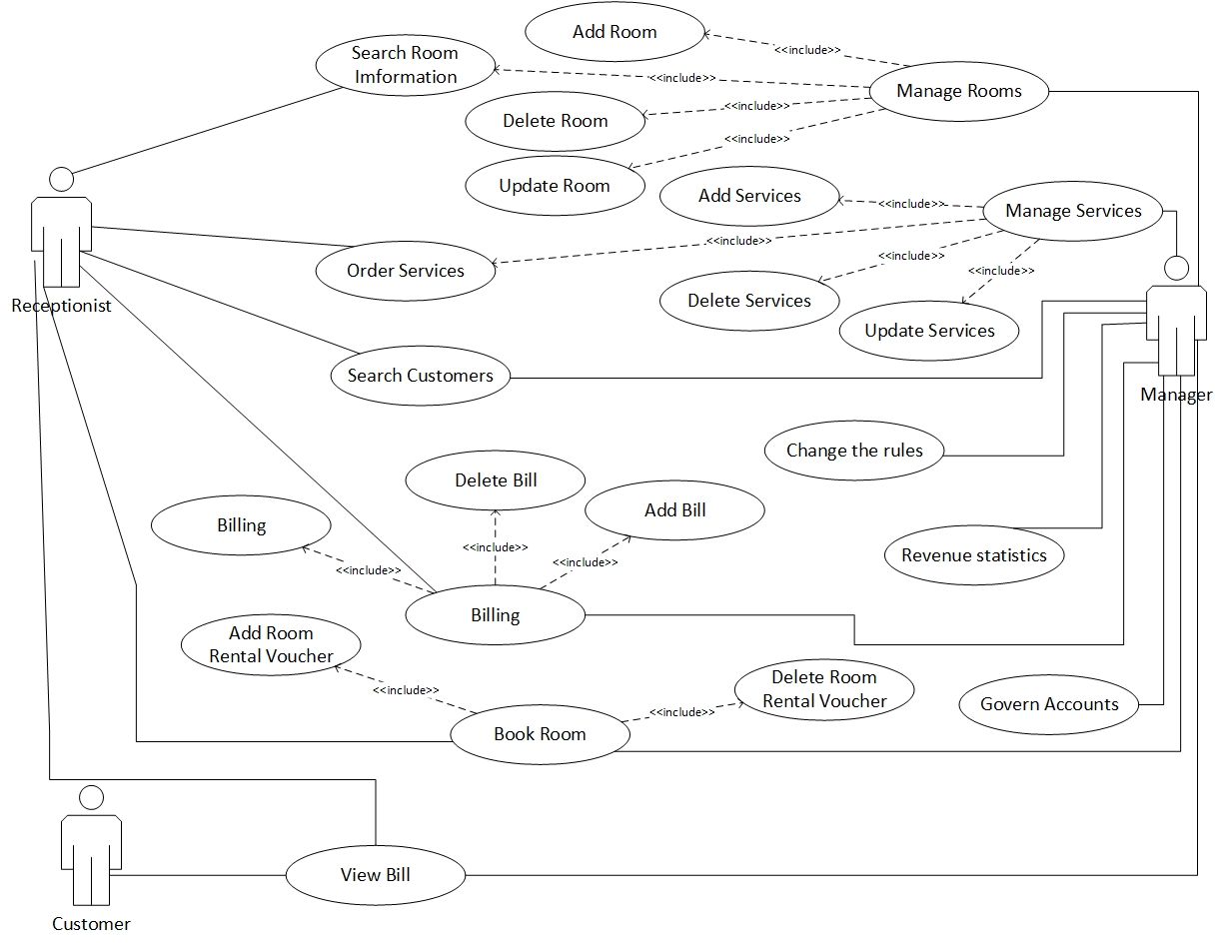

**H2. Use Case Diagram**

**2. BUSINESS PROCESS ANALYSIS**

**2.1.Use Case "Login" specifications**

|  |  |
| --- | --- |
|  | |
| Purpose | User log in the system based on permision |
| Description | Allow user to log in to use the functions that supported for these kinds of user |
| Actor | Receptionist and manager |
| Pre-condition | Access the hotel management software |
| Basic flows | - Enter username  - Enter password |
| Alternative Flows | - Fail to log in because of wrong username 🡺 Re-enter  - Fail to log in because password does not match 🡺 Re-enter |
| Post-condition | Log in successfully and start to use other functions of the system |

**2.2. Use Case “Create new account” specifications**

|  |  |
| --- | --- |
|  | |
| Purpose | Provide account for user |
| Description | Enter user information |
| Actor | Manager |
| Pre-condition | - Log in successfully with administrator permision  - Click "Staff" on "Admin"  - Click button "Provide account" in this form |
| Basic flows | Enter user name, password for user account |
| Alternative Flows | User account information is stored in Database |
| Post-condition | Enter username, password for user's account |

**2.3. Use Case “Change Password” specifications**

|  |  |
| --- | --- |
|  | |
| Purpose | Change user password |
| Description | Change user password |
| Actor | Manager + Attendants |
| Pre-condition | - Log in successfully  - Click "Account" in Main menu  - Choose "Change password" |
| Basic flows | Change user account password |
| Alternative Flows | Informations are saved in database |
| Post-condition | Change user password |

**2.4. Use Case “Reservation” specifications**

|  |  |
| --- | --- |
|  | |
| Purpose | Reservation |
| Description | Check room list and show customer the room that not currently in use, then connect to reservation data |
| Actor | Receptionist |
| Pre-condition | - Log in successfully with Receptionist permision or higher  - Click “Room”, then “Reservation” This time room list displays  - Choose room by images or room number. |
| Basic flows | Reservation for customers |
| Alternative Flows | Out of room or don’t meet the customer's requirements 🡺 Reservation ends |
| Post-condition | Reservation complete, save reservation and customer data. Update room status from "Free" to "Currently in use" |

**2.5. Use Case “Check out” specifications**

|  |  |
| --- | --- |
|  | |
| Purpose | Check out by demand of customer or out of time |
| Description | Process of payment, printing invoice and updating status of room, Delete guest list. |
| Actor | Receptionist |
| Pre-condition | - Log in successfully with Receptionist permision or higher  -Click “Room”, then “Check out”. This time room list displays  -Click onto room in list, Click “Add invoice” to invoicing.  -Click “Pay” to print invoice for our customer. |
| Basic flows | Add and print invoices. |
| Alternative Flows | Customer have response about invoice(bill) or want to cancel reservation 🡺 Delete invoice to re-check invoice information. |
| Post-condition | List of rooms, customers is updated by data and status |

**2.6. Use Case “Add room” specifications**

|  |  |
| --- | --- |
|  | |
| Purpose | Add room for rent |
| Description | Add room for rent into database. |
| Actor | Manager |
| Pre-condition | -Log in successfully with manager permision.  - Click “Manager”, click “Room management”. This time room list displays  - Click “Add room” to enter information of the new room. |
| Basic flows | Type Room Code, Room Status, Room Type, Price and Note |
| Alternative Flows | Newly added room's code is duplicated 🡺 Re-enter |
| Post-condition | Room list is updated. |

**2.7. Use Case “Delete room” specifications**

|  |  |
| --- | --- |
|  | |
| Purpose | Delete room that will be not in use out of the system |
| Description | Delete room that will be not in use out of the system |
| Actor | Manager |
| Pre-condition | - Log in successfully with manager permision.  - Click “Manager”, click “Room management”. This time room list displays  - Click onto the room you want to delete. Click “Delete room” to delete data of that room. |
| Basic flows | Delete room from list |
| Alternative Flows | Chosen room is at status "Full" or "Repairing" 🡺 Delete room is not permitted |
| Post-condition | Room list is updated. |

**2.8. Use Case “Update room” specifications**

|  |  |
| --- | --- |
|  | |
| Purpose | Edit room information |
| Description | Edit room information |
| Actor | Manager |
| Pre-condition | - Log in successfully with manager permision.  - Click click “Manager”, click “Room management”. This time room list displays  - Click the room that you want to edit. Click click “Update room” |
| Basic flows | Enter room status, type and notes |
| Alternative Flows | Click "Stop" -> Cancel update room |
| Post-condition | Room list is updated |

**2.9. Use Case “Add service” specifications**

|  |  |
| --- | --- |
|  | |
| Purpose | Add new service |
| Description | Add new service when add service |
| Actor | Manager |
| Pre-condition | -Log in successfully with manager permision.  - Click “Manager”, click “Manager service”. This time service list displays  - Click “Add service” then enter information about new service. |
| Basic flows | Service được add mới |
| Alternative Flows | New service code is duplicated 🡺 Re-enter |
| Post-condition | Service list is updated. |

**2.10. Use Case “Delete service” specifications**

|  |  |
| --- | --- |
|  | |
| Purpose | Delete services that are no longer supported |
| Description | Delete services that are no longer supported |
| Actor | Manager |
| Pre-condition | -Log in successfully with manager permision  - Click click “Manager”, click “Manager service”. This time service list displays  - Click “Delete service” to delete that service. |
| Basic flows | Delete service out of database. |
| Alternative Flows | None |
| Post-condition | Service list is updated. |

**2.11. Use Case “Update service” specifications**

|  |  |
| --- | --- |
|  | |
| Purpose | Update service information |
| Description | Create list of the thing that customer require |
| Actor | Manager |
| Pre-condition | -Log in successfully with manager permision  - Click click “Manager”, click “Manager service”. This time service list displays  - Click “Update service” to change service information. |
| Basic flows | Enter service name, unit, price. |
| Alternative Flows | Service data is stored in database |
| Post-condition | Service list is updated. |

**2.12. Use Case “Order services” specifications**

|  |  |
| --- | --- |
|  | |
| Purpose | Order services for customers to select |
| Description | Customer call the Receptionist to request for a service. Receptionist will execute the resquest |
| Actor | Receptionist and Manager |
| Pre-condition | - Log in successfully with Receptionist permision or higher  - Click “Manager”, then “Service management”, choose “Order service”. Or click “Room”, then “Order service”. This time order service table display |
| Basic flows | - Enter room code - Click service name - Enter quantity |
| Alternative Flows | Close 🡺 Cancel Oerder |
| Post-condition | Information about "Order services" is saved to attach into invoice |

**2.13. Use Case “Room search” specifications**

|  |  |
| --- | --- |
|  | |
| Purpose | Check information of rooms in hotel |
| Description | Provide information by room, price, availability |
| Actor | Receptionist + Manager |
| Pre-condition | - Click search button  - Click "Room search" button |
| Basic flows | - Click type or price range.. to show proper room information  - Click empty ,Click button "Reservation". |
| Alternative Flows | Room doesn’t found 🡺 Search again |
| Post-condition | Information list of rooms |

**2.14. Use Case “Search customer” specifications**

|  |  |
| --- | --- |
|  | |
| Purpose | Search for detail customer information |
| Description | See in detail customer information |
| Actor | Receptionist và manager |
| Pre-condition | Log in successfully with Receptionist permision or higher   * Click search button * Click “Search customer” in "Admin" |
| Basic flows | - Choose customer by writing their name (customer's name, address, customer type, room code) in search box.  - Show customer information |
| Alternative Flows | -Search is failed because of wrong information 🡺 Re-enter |
| Post-condition | List of customers with detail informations |

**2.15. Use Case “Change regulation” specifications**

|  |  |
| --- | --- |
|  | |
| Purpose | Reinstall important value of the system |
| Description | Update: price, surcharge, coefficient, number of customers |
| Actor | Manager |
| Pre-condition | - Log in successfully with manager permision  - Click "System", choose "Change regulation" |
| Basic flows | - Choose parameters  - Enter new values  - Click "Update" to save |
| Alternative Flows | Parameters are not entered 🡺 No update occurs  Close 🡺 Section ends |
| Post-condition | Change regulation of the system |

**2.16. Use Case "Turnover statistics by room type"**

|  |  |
| --- | --- |
|  | |
| Purpose | Check turnover statistic by room type |
| Description | Calculate turnover statistics in each room in specific period of time |
| Actor | Manager |
| Pre-condition | - Log in successfully with manager permision  - Click "Turnover" in "Admin"  -Click "Turnover by room type". |
| Basic flows | - Click reservation time.  -Click button "Show statistic" |
| Alternative Flows | -Enter wrong format data type |
| Post-condition | Turnover statistics in each room in specific period of time |

**2.17. Use Case “Show used service list” specifications**

|  |  |
| --- | --- |
|  | |
| Purpose | To compare with the invoice (bill) |
| Description | When customer requests service, the history will be stored |
| Actor | Manager |
| Pre-condition | - Log in successfully with Receptionist or manager permision  - Click “Invoice list” |
| Basic flows | Enter room code and reservation time |
| Alternative Flows | Wrong room code 🡺 Re-enter  Reservation time doesn’t not match 🡺 Re-enter |
| Post-condition | Corresponding service list is shown |